# Subsetting Lists of Lists - Python Exercise

Below is the image provided along with the recreated question, terminal output, and answer:

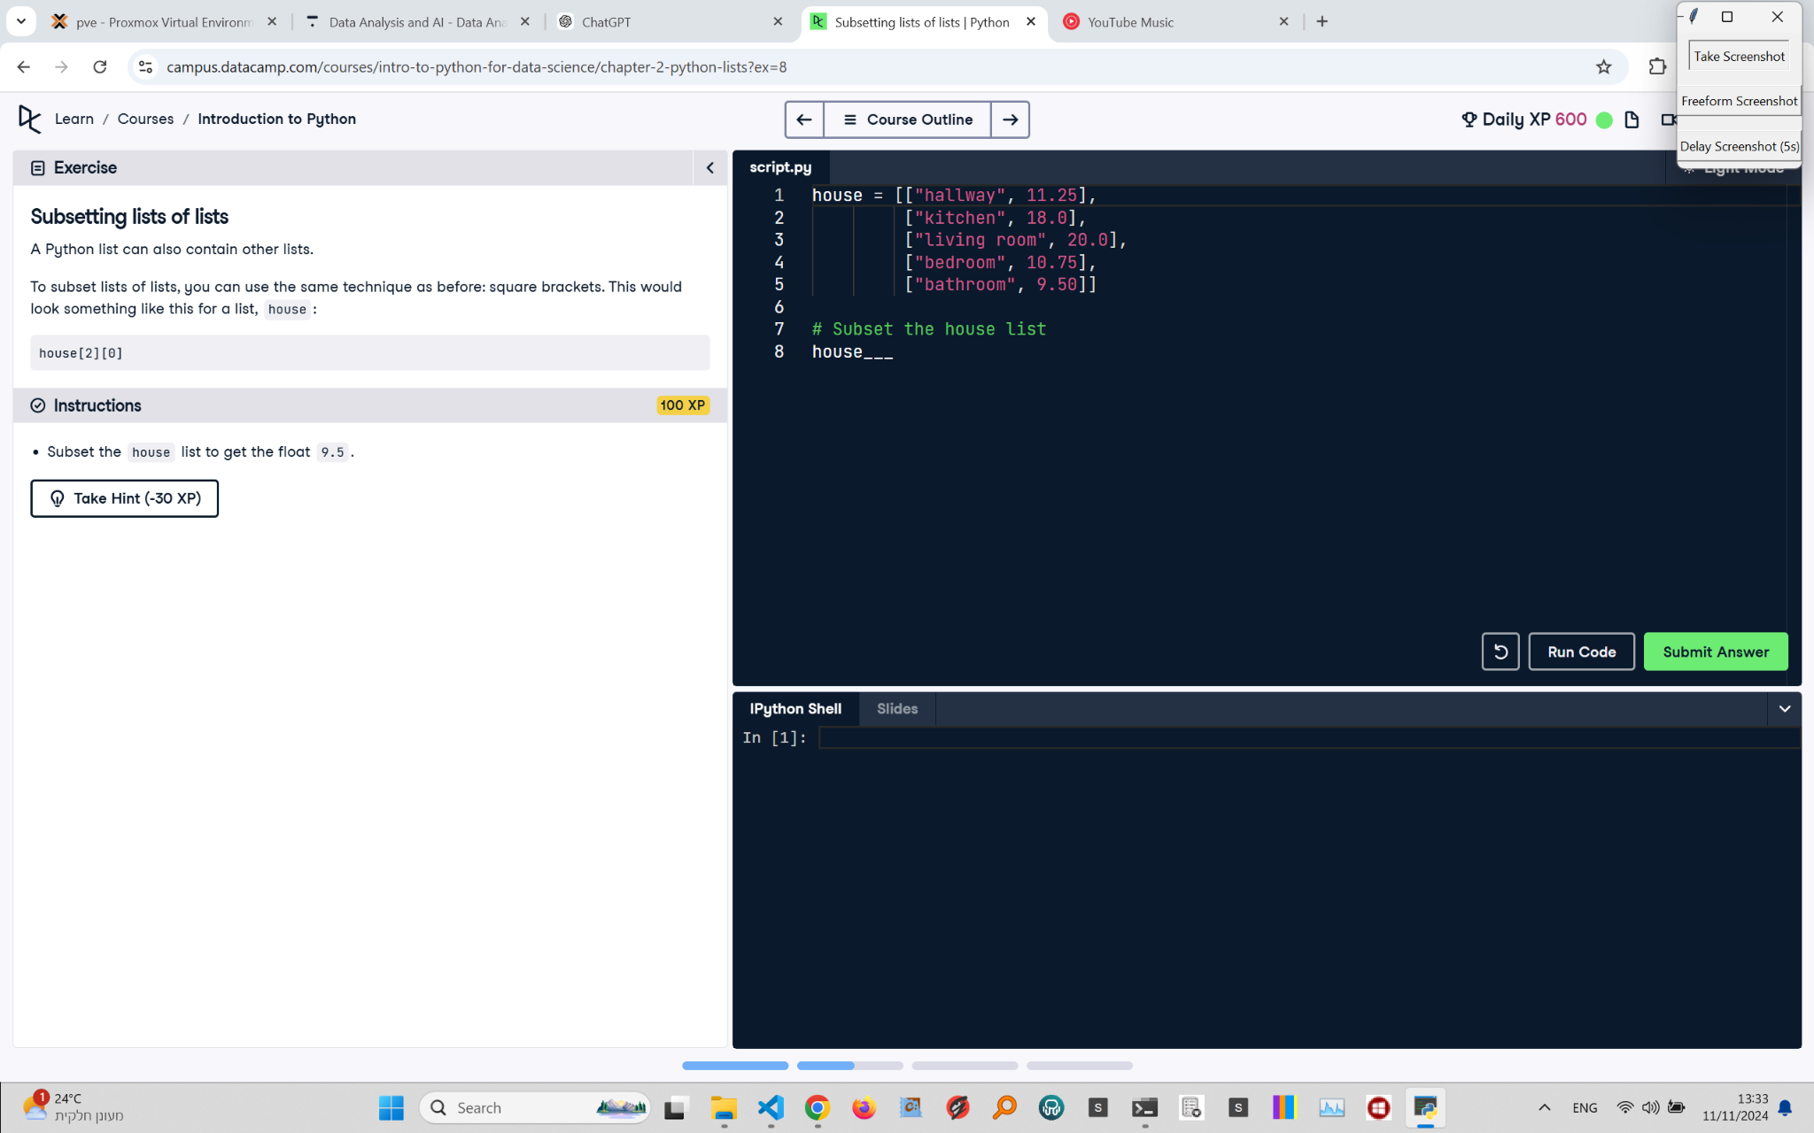

## Recreated Question and Terminal

Subsetting Lists of Lists  
A Python list can also contain other lists.  
To subset lists of lists, you can use the same technique as before: square brackets. This would look something like this for a list, house:

house[2][0]

Instructions:  
- Subset the house list to get the float 9.5.

## Answer

# Given list of lists  
house = [["hallway", 11.25],  
 ["kitchen", 18.0],  
 ["Living room", 20.0],  
 ["bedroom", 10.75],  
 ["bathroom", 9.50]]  
  
# Subset the house list to get 9.5  
print(house[4][1])

## Explanation of the Answer

The code accesses the nested list containing "bathroom" and 9.5 using house[4]. Then, to get the float 9.5, we use house[4][1]. The first index (4) selects the "bathroom" list, and the second index (1) selects the second element, which is 9.5.